For Sale – Steel Gun Cabinet (Grey) - £ 75
- 3 x Shotguns
- Dual Key Locking (Different Keys)
- H 1280 x W 235 x D 220 (mm)
- Wall Mountable
- Ammo storage: No

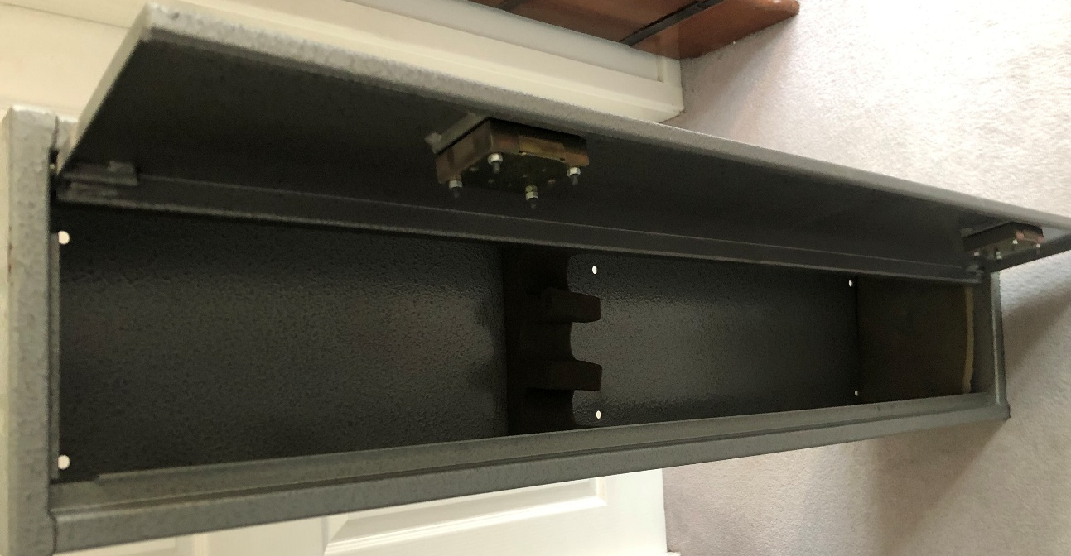
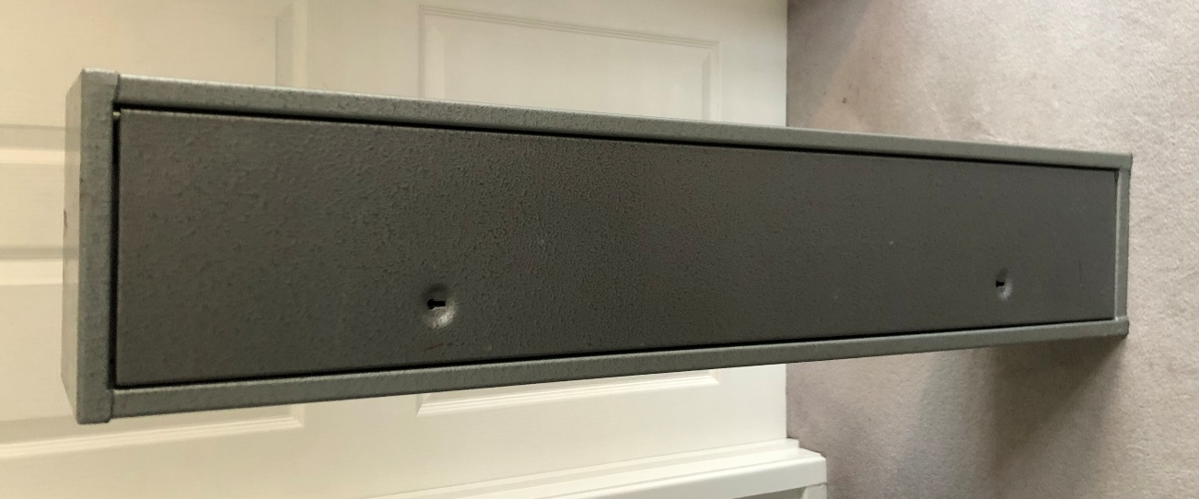

Steve 07889-705022 – Market Harborough

